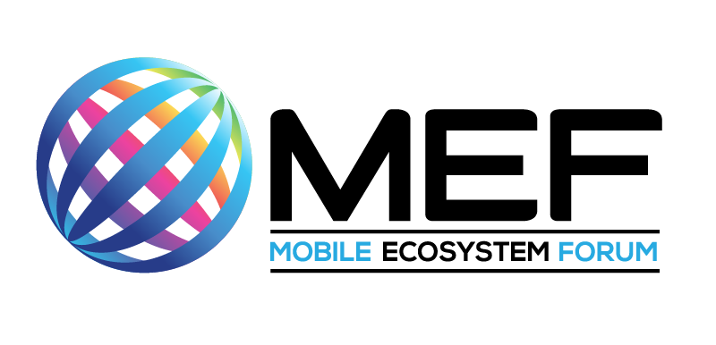

The Metaverse

A Driver of Real Change for People with Disabilities

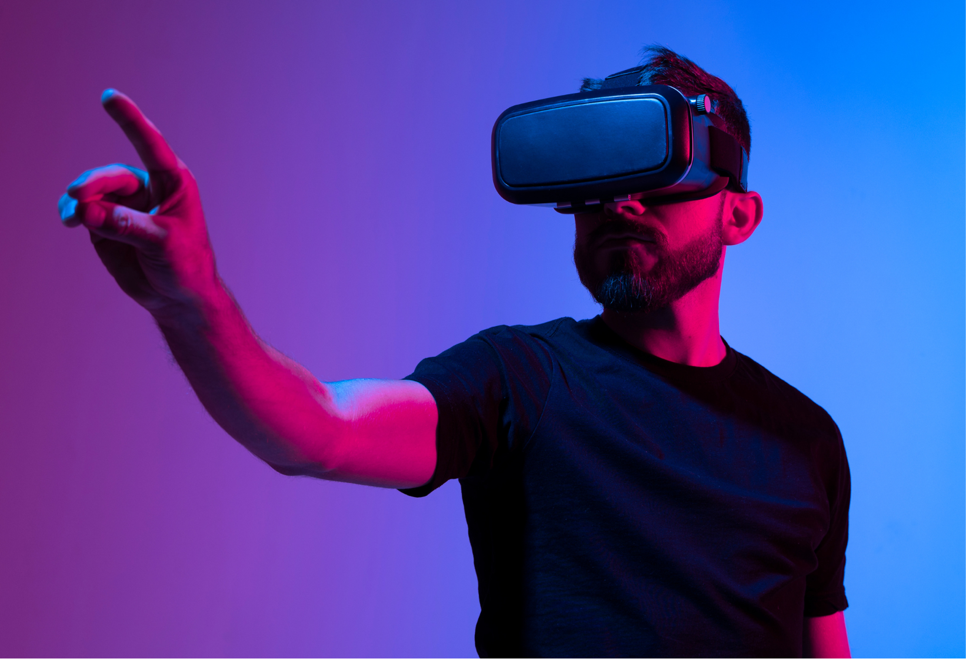

November 2022
achieving mass adoption

C NTENTS

Designing customer experience around excluded segments benefits everyone! 3
Introduction 3
Background 3
The communications cycle 4
Excluded groups and their interactions with the telecoms industry 5
Identity and Personal Data 6
The customer experience across its different channels 7
What channels are open to provide the interaction? 8
What needs to be in place in order for this more balanced customer interaction to be a reality? 9
Employment opportunities 10
A glimpse into the future 11
Inclusive design 12
Conclusions 13
About the Author 15

Designing customer experience around excluded segments benefits everyone!

Introduction

In a previous report we addressed the market for People With Disabilities (PWD) alongside their requirements and the role that technology can play in bringing them into the digital economy. What is evident, as we delve deeper into the topic, is that PWDs aren’t the only groups to be excluded from the telecoms and related marketplace. The ‘Silver’ market requires some close attention, as do those not even currently able to connect for network reach reasons or for lack of awareness and education about how to use the services. So, in any given market we have a very significant proportion of potential customers not considered as ‘mainstream’ and for whom the services need to be rendered in a different way.

This report takes a new perspective on the subject. It looks at how channels of communication can be used to improve the potential for these excluded groups to join the digital marketplace, hence providing new revenue opportunities for the industry as well as bringing the societal benefit of having everyone connected.

Background

The telecoms industry is often seen as being inward looking, technology centric and conservative.

The focus is usually on the generation of communications technology being deployed and how it is transforming. However, standing in the shoes of those using the services delivered by the industry provides very different perspective. The benefits of all of the technological and transformational changes rarely match the narrative of the industry and the marketing hype that accompanies it.

This is partly explained by telecoms and its connectivity services being one step removed from the individual’s daily activities. Yes, connectivity underpins what people are doing, but even the good old-fashioned phone call is now being replaced by FaceTime, Zoom, Teams, WebEx and WhatsApp calls, to mention but a few. The transactions we execute by the billions every day are related to applications and the devices we use and not the underlying transport provided by the telecoms industry.

So, it is not surprising that interaction with telecoms providers for customer service reasons, billing and related account issues are often seen as necessary evils rather than enhancing the interactions with a trusted provider.

In the past, work around PWDs has focused on the individual disability and how the technology available today brings the estimated billion disabled people closer to the digital experience of the so-called mainstream market. Thinking about the customer experience and the channels through which people interact with the world’s telcos raises a much more important issue – that of building a consistent experience across all channels whomever the customer is and what preferences or restrictions they might have. It is the notion of Inclusive Design where all possible permutations are taken into account at the outset rather than being a clumsy add-on.

The communications cycle
Before delving into how we can improve how these excluded groups can be drawn into the market, it is worth reflecting on how communications have evolved. This is by no means a full analysis of the subject, but it serves to make us reflect on how we, as humans, communicate and how the industry we all represent might influence how we do things going forward. The sequence goes something like this:
- We started off grunting and gesturing at each other
- Early forms of ‘written communication’ were developed to capture thoughts and images of our activities
- Languages evolved on regional and tribal bases
- Alphabets emerged and we began to write things down
- The printing press revolutionised the writing and production of texts away from the hand-written works of art coming out of religious establishments
- We computerised text and turned it into digits
- Keyboards evolved as input devices and screens as output/consumption devices
- Touch screens came along, and we returned to tapping and gesturing
- Speech recognition evolved and we started talking at our devices
- Gesturing and perhaps even grunting at our devices was enabled from laptops to smart phones and smart speakers to televisions

And if this isn’t complicated enough, we are entering a period of research where brainwave interpretation is gaining significant attention to suggest that it might be a usable option. This is a step into the real future and comes with a lot of very serious questions about exploitation. But it potentially opens up a whole new channel of interaction for those unfortunate enough to be suffering from locked-in syndrome and similar issues.

Whether this is a cyclical or linear progression it is difficult to say. What is evident is that it gives us a wider range of options as to how we communicate with each other, and furthermore, with the advent of Artificial Intelligence, how we interact with Things and systems. This variety of means of communications can be mapped on to the different ways in which individuals might be impaired from interacting with anyone, let alone the telecoms service providers and related applications and content providers.

Excluded groups and their interactions with the telecoms industry
As discussed in previous reports, the technology developed for different disabilities and for the elderly, were developed in isolation, were often clunky add-ons and suffered from high price tags and relatively low penetration. The fact that smart devices as well laptops etc often offer these options as part of their standard design, means that we finally have the scale to address these exclusions on an affordable and inclusive basis. In simple terms, the accessibility and inclusion market has gone mainstream.
There are several different ways in which we should view the issue:
- How the individual behaves at home or out and about
- How that individual prefers to interact with their Service Provider
- How the User Interface (UI) is designed to ensure accessibility from the device manufacturers point of view
- How the right standards are embraced and APIs are implemented by the applications developers
- How telecoms service providers’ systems and processes are implemented to address these formerly excluded groups

And for everyone:
- How web sites and related contented is tagged correctly and compliant with relevant access regulation
- How content is created and delivered

One area of consistency worth a mention is that of short cuts and hot keys in applications. Nothing has been more frustrating for users of assistive technology than the lack of consistency when it comes to using apps. The explosion of webinars, online interactions, and collaboration tools available to a more dispersed workforce, in some ways play into the hands of those using assistive technology and has been a blessing for many.

However, the frustration when it comes to consistency of hot keys and short cuts is a nightmare. Almost every collaboration application has different short cuts for muting and unmuting, turning video on and off, entering the chat and Q&A function. And, of course, if graphics, buttons and icons are poorly labelled, the users of screen readers are left out in the virtual cold.

W3C’s standards along with toolkits from the main mobile device providers make life easier, but a lot of work is required to ensure these are universally applied.

Identity and Personal Data

This raises the sensitive question as to how we want to be identified as a customer. It also has implications on how we are categorised as customers within the Service Provider segmentation.
In simple terms, should someone with an issue that affects their ability to interact with a telecoms provider be forced to reveal their impairment? Of course, this is the choice of the individual. What is evident from the statistics surrounding disability is that a good proportion of the vision, hearing and cognitively impaired do not self-identify as such. We talk about invisible disabilities. All disabilities are invisible when it comes to the contact centre hence impacting potential interactions.

Dedicated ‘Disability Lines’ already exist in different industries. Airlines are a good example where PWDs may require special assistance navigating through an airport and on the aircraft. This manifestation of ‘reasonable adjustment’ by the airlines is a good guideline for the telecoms industry. However, if the individual does not recognise the need for adjustment then this leaves some very grey ground between the different parties involved.
Furthermore, if an individual is using special features on laptops, tablets or smart phones, such as magnification, screen reader, low light or adapted text, then this should be a good indication to the apps and web sites being used that some modification is needed.

But ultimately it is down to the individual to request assistance and the telecoms provider needs to ensure all the right systems and services are in place to deliver that assistance.
Based on the customer profile history, the Service Provider should be able to adapt the interaction accordingly. This assumes that all interactions are logged, brought together in a single virtual repository, and the profile of the individual brought forward whenever an interaction is initiated.

This begs the question about how data is handled within the relevant regulations. It is all too common to hear that a particular mobile operator, broadband provider or MVNO just doesn’t have all the relevant information about an individual in a single place. The single source of truth is perhaps a goal out of short term reach for many players, but it has to be a long-term target if embracing all customer requirements is to be addressed. And yes, Artificial Intelligence (AI) has a major role to play in bringing all the data together and interpreting it in favour of the customer.
Perhaps this is the nub of the issue: that the telecoms industry has been gathering information and interpreting it for the benefit of the company rather than that of the individual!

The customer experience across its different channels
We have gone through the shift away from written correspondence, the closing of many high street retail outlets, the shift to mobile first and the digital first approach. Thinking of the issue from the excluded groups’ point of view, it is impossible not to conclude that a human first or customer first has got to be the best approach.

As an industry, we have always focused on the technology at our disposal. As a customer, it often feels that the technology has been the focus and the customer a necessary evil at the end of the experience. We even measure things inside the network and claim them as proxies for the actual customer experience. So, rather than starting with the technology behind the ‘omnichannel’ model, we should start with why people interact with their telecoms and related service providers. This is important, since the best connectivity service is invisible to the customer. When it works properly the customer is unaware of it. In fact, we only tend to notice the problems with connectivity when other applications fail to work properly.

A cursory look at reasons for contacting mobile or fixed service providers would include:
- Reporting a problem
- Complaining about the service
- Billing issues: does the bill make sense, am I paying for what I am using?
- Service renewal or upgrade
- Buying additional package components
- Thank the service provider for great service (just checking if you are reading to the end!)
Since many interactions are regarding problems, it is questionable whether the Net Promoter Score (NPS) is really measuring how happy people are with the service. As previously discussed, an invisible service is best for the customer. Having to contact the provider and fighting your way through the labyrinth of contact centre, websites and app options often fills the customer with trepidation. Whichever one is in play, the question remains how accessible they are to the customer.

The contact centre was always the first port of call if the high street retail outlet wasn’t available. The use of IVR and choosing from a range of options can prove too much for people with cognitive issues, hearing impairment or without the dexterity to push the right buttons. In fact, it is the sheer anxiety of contacting a provider that is shaping everyone’s interactions, not just those with particular accessibility issues.

Naturally online interaction is the telecom’s preference given its efficiency, but it also presents barriers for those with sight impairment not able to identify links, buttons, graphics and other trigger points on often ill-designed web sites. Vision Impaired people complain about having to tab literally a hundred times before finding the right option. And by that point, the individual has often given up hope of finding anything relevant!

Chatbots require typed information and are obviously not suitable for those with dexterity or input issues as a whole.
Entering information into fields for payment and other required data can be a major issue for many of the excluded groups. And, of course, given the lack of credit card and online banking in many parts of the world, this information might not actually exist. This is not even to mention peoples’ valid concerns about how their data is handled and the potential risk of online fraud.

The omnichannel offering is supposedly based on all channels being interchangeable but in reality, jumping between channels is not possible.

What channels are open to provide the interaction?

The industry talks about the customer journey and keeping track of all activities along that journey. The value for the customer is a personalised experience, and for the telecoms provider the value is in the collective data.
The danger is having ‘rules’ pushing customers towards a particular channel when that channel might be excluded to them either permanently or temporarily.

Some are self-evident:
- Websites are excluded for the vision impaired for those not able to use screen readers or where appropriate magnification or colour contrast is not in place
- Hearing impaired cannot use regular contact centre IVR systems or speaking to agents
- Different cognitively impaired individuals may not be able to cope with the different options on an IVR system, let alone with the wealth of data provided on a website or app
- Chatbots aren’t for everyone, with the dexterity of typing and understanding the nature of interacting with either a BOT or a person on the chat
- Elderly customers may struggle with providing their details and sheer complexity of the offerings.

Since we are talking about the telecoms industry, we often forget the high street is still an option, as are printed bills and postal communications. Some people still prefer these ‘old-fashioned’ means of communicating with a service provider. And, to confuse matters further, some operators still send printed bills and notices which are of little use to the vision impaired and can cause anxiety at best or termination of service at worst if not understood.

What needs to be in place in order for this more balanced customer interaction to be a reality?

Anyone thinking the issue of PWDs and other excluded groups is ‘only’ something for Corporate Social Responsibility (CSR), Environmental Social and Governance (ESG) or Equality Diversity and Inclusion (EDI or DEI) focus of the business need to rethink. Everything must lead to all elements of the business being designed inclusively from scratch. It is actually part of the long term sustainability of telecoms and related industries. After all, everybody agrees that anyone excluded from the benefits of the digital, virtual and e-commerce worlds should be brought into the fold. The interchangeability of channels and means of interaction will benefit everyone and provide some incremental revenue to the industry whilst also providing vital societal contributions in terms of inclusion and public service.

Yes, it means more effort when creating content. But thinking about the Metaverse will make us more conscious of what we used to call multimedia. It isn’t just about the fancy graphics. High quality sound and captioning is equally important to create the feeling of being inside the content, app or interaction. We are deliberately aiming to boil the ocean here or at least create a framework within which it could be boiled. The beauty of this approach is that we can take individual elements and create a more inclusive experience.

Accessibility tool kits for mobile apps from the device manufacturers shouldn’t only be used in the initial design but must be included in the refresh cycle. All too often updates leave out accessibility requirements leading to negative impacts on the PWD’s customer experience.

Equally empathy for all the excluded categories needs to be built into the processes, training and overall culture of the contact centre and associated services. Agents’ understanding and acknowledgement of the individual’s requirements is key to this holistic view. It is impossible for anyone to have a full understanding of how a vision impaired, hearing impaired or cognitively impaired person experiences the call centre, but awareness of the variety of issues can only help shift the situation from ignorance to empathy.

Ultimately, putting the person first and then building the customer interaction channels inclusively is the goal. This must come from the very top of the organization with inclusion in mind but most importantly, must be part of the DNA of dealing with every customer on a basis of individual preferences, not on the basis of the preferred technical solution of the architect in charge of the telecoms provider!

In fact, understanding the context within which an individual approaches an organization, whether a consumer, a support person or an employee of a business should shape how the interaction takes place and how it develops.

Employment opportunities

The focus here has been on the customer experience and how all the available solutions can bring excluded groups into the mainstream. Designing systems and processes with inclusion in mind also opens up employment opportunities.

After all, once different channels of communication are fully accessible, they can equally be used by employees from excluded groups as part of service delivery. Vision impaired people used to be employed as switchboard operators, plugging and unplugging jacks on Strowger switchboards. Assuming the availability of a single source of truth about a customer is in an accessible format, then an employee in similar circumstances could easily be a contact centre agent helping that customer through the process of subscribing, changing preferences, or solving problems. The same is also true for hearing impaired people who could be employed for example on chatbots, or indeed on any customer interaction that doesn’t require verbal communication. Having said that, the use of video and a blend of lip-reading and signing could also be a channel development for both employment and customer service. Think of the expansion of smart speakers with screens to include high quality video with the added benefit of helping the hearing impaired get information and service.

Furthermore, as the telecoms industry shifts gear and enters a more software-centric and cloud-based era, training employees with different impairments to become the coders of the future is another untapped source of talent, so often claimed to be a major blockage for the industry today. Indeed, some companies are actively targeting particular groups of neurodiverse people with their unique skills.

Testing compliance with accessibility has to be built into the cycle. So, whenever any content is changed, apps are updated, or new products launched – inclusive testing must be part of the final sign off.
Once again, the technology is there to allow these developments to happen. However, this inclusive future requires a change in culture from the very top of an organization combined with awareness of the benefits from the customer experience, commercial and employment implications.

A glimpse into the future

The idea of Brainwave Computer Interfaces (BCI) takes us not into the realms of real science fiction, but, in fact, science fact. Talk of the Metaverse and how we will live our physical and virtual lives raises some serious questions about the relationship between the individual, businesses, and those we interact with as part of our personal and business lives.

If those currently excluded from the digital world are to be included in the Metaverse, then the issue of inclusive design must be built into the processes and procedures for all Metaverse activities. In fact, whether we call it the Metaverse or not doesn’t matter. Whatever services are built for the future, we must ensure that everyone has equal access to the services and the benefits of being part of this world.
With disability in mind, there is an interesting philosophical question worth raising: is the disabled person digitally twinned as a disabled person or is the option there for them to live their digital life as fully able-bodied?

This raises several issues:
- By modelling PWDs in the Metaverse can ‘we’ better understand how others live their lives, experience the world around them and therefore be more easily integrated into society and business?
- Can the digital twin feed information back to the individual in a suitable format to help for example, navigate their way around the physical world?
- Can channels of interaction be built to cope with all of the permutations that this parallel world brings?
- Could learning from the simulation of the real-world help design products and services to better service both PWDs and other excluded groups?
- Does it provide an opportunity for an individual to ‘play’ in the Metaverse as a fully able-bodied individual when, in fact, they are impaired in various ways in the real world?
One of the key developments shaping the Metaverse is the Virtual Reality and Augmented Reality headset. Miniaturizing this to nothing more than a pair of glasses or other wearables will help everyone, as it will bring affordable communications of all types to the mass market. It is interesting to note how Research & Development in the disabled world and in the Metaverse are not that far apart. Work on smart glasses/headsets for the vision impaired and hearing impaired are looking more and more like those coming out of the giants of Meta/Facebook, Google, Amazon and Microsoft, let alone the wealth of start-ups trying to get a foothold in this market.

This is an exciting time for everyone. Once again, the issue is not to forget to include the accessibility and broader inclusion requirements in the design of all wearable and smart devices that will be used as part of the future personal and working environments.

Just think of a scenario when a local doctor can virtually visit an elderly patient in a care home via high quality interactive broadband on both ends and via haptic and virtual reality glasses and gloves. It raises massive issues of how data is shared from all of the sensors at play, who that data gets shared with, and how it informs the interaction of the individual with the social, healthcare and insurance sectors let alone family and carers.

Whatever your preferred science fiction influence, we can see how this is becoming a reality. The question is how to build the customer interaction into these systems, the role that connectivity plays, and how society as a whole benefits from it all. Will a spike in blood sugar trigger a call from your doctor? Will the smart speaker be managed by brain waves in the future? Of course, these scenarios open up a whole can of worms for regulators as well as those trying to exploit the technology for profit.

In short, this embodies a shift from fragmented communications to a fully immersive 3D experience. The virtual world holds enormous potential for smoothing out inequities as long as the systems are fully embracing it and individuals are educated as to how they can benefit from such designs.

The impact on channels of interaction is significant. Volume of interactions is one thing, but the complexity of all systems and processes keeping up to speed with this new environment is enormous.

Much of the interaction will be handled by various forms of AI, continually updating itself through Machine Learning. But the individual has still got to have access to all relevant information and be able to check the status of all services at any time.

It is likely that the connectivity services will be embedded into more and more applications, services and functions supporting us in our personal and business lives. Keeping track of the connectivity, transactions and management of everything is going to be a major piece of integration and management.

In the future, will we as individuals, negotiate with our service providers? I suspect not. Our domestic AI systems will find the right service and the right price. This will take some of the inequity out of the system, with for example, elderly people purchasing the appropriate service for their circumstances and will result in a much more robust landscape.

The complexity of telecoms packages, mobile or fixed must be simplified. Access to the right deal for the individual and not the most profitable for the telecoms service provider is the natural outcome of this ever more AI influenced marketplace.

Inclusive design

The interest in Inclusive Design from so many corners of every industry is indicative both of the opportunity out there, but also the diverse perspectives that need to be brought together. It is part of everything we do in the telecoms industry. At every stage we need to embrace the notion of inclusive design.

Why is this so important? Having previously designed with the ‘norm’ customer in mind. Anyone not conforming to the norm would require additional technology or adaptation to get to the service.

By designing for all peripheral segments from the start, those fitting the norm will actually get a better service. Some academics looking at this topic talk about designing for the edge and getting the centre for free! Jutta Treverinas at the University of Toronto and Rama Gheerawo at the Royal College of Art are both experts in this field
So, don’t design for your ‘ideal’ or ‘target’ market, but design for everyone. The resultant design is simpler and often more intuitive rather than being dictated by the underlying technology.

Conclusions

The telecoms industry has historically taken a technology first approach to building our systems, processes and offerings. This has shifted today to a digital and indeed, mobile first approach when in fact we need to take a human first approach if we are to equitably serve all end user groups including those currently excluded on the basis of disability, age or economic power.

In the past technological solutions to help different excluded groups were expensive and clunky and these segments failed to reach any level of scale. However, we can now centralize our approach and bring all segments into the mix. This will be greatly facilitated by the automation and simplification of the underlying networks and processes.
The industry is bringing together services and systems that were previously isolated from each other. The need for interchangeability between different channels of communications with customers is a clear example of how a unified and integrated approach will benefit all parties. After all, a customer centric approach needs to deliver the services that customers want in a way that they can be consumed. If one channel is cut off for whatever reason, cleanly integrated and interchangeable options need to be available.

And, since all systems and processes are going to be designed with accessibility and inclusion in mind, this will create employment opportunities inside the telecoms technology and service provider communities, further benefiting each side of the equation when it comes to dealing with PWDs and other excluded parties.

Bringing these formerly neglected markets into the core design of products and services results in an expanded total addressable market as these excluded groups have significant economic power and want to be part of the connected world.

Education at all levels is a critical factor. Senior management must be aware of the need to design inclusivity from scratch and to maintain inclusive design with every refresh of software, applications, services and customer experience measurement.

Inclusive design means that the previously peripheral use cases are already embedded when we start designing. In this way the so-called mainstream markets are addressed by default when we build the peripheral use cases into the software, hardware and interaction options design.
Focusing on the customer journey delivers a very different outcome than starting with the inner workings of the telecoms industry.

Customer interaction may well start with smart speakers, smart phones or laptops. And, most importantly, it will often still include the traditional phone call. The options made available to the customer must allow for swapping between channels and not assume that a digital first, mobile first or web-centric solution is ideal for everyone.
A single source of truth when it comes to data about the customer is essential as the experience is negatively impacted by a lack of knowledge of previous issues. Bringing all the formerly disparate sources of data about the customer together is a major task but one that will pay dividends. At the same time, the customer’s right not to identify as being a PWD or one of the other excluded categories presents some issues. Gaining the customer’s permission to store such information for the purposes of rendering a more suitable service needs to be seriously considered.
Assumptions built into the design of customer interactions need to be carefully considered in the world in digital first. Gen Z may well prefer chatbots, but the elderly market might prefer good old-fashioned voice. Even with fully compliant accessibly websites and apps, PWDs may not have the knowledge or dexterity to navigate them. And, in less developed markets, voice and text may be the only channels available.

Thinking further ahead, the Metaverse brings a whole fresh set of channel, data, and interaction options for all customers. Keeping track of all activities, customer experience and data across digital twinning, consumer and enterprise applications and interactions may well see the connectivity components embedded into, for example, a health care offering, gaming players and items such as autonomous vehicles. Connectivity will influence the customer experience, but the end service will be delivered potentially by another party in the ecosystem.

So, automating and simplifying the way telecoms services are delivered will ensure the expansion of services through emerging B2B2X business models. It is a change of proposition for the world’s telcos but it is the future.
Thinking about it philosophically, we have gone from grunting and gesturing in the early days of humanity and have returned to gesturing at least! The technical options available to use today mean that we can more easily embrace all potential forms of communication to deliver the required service. We do not need to restrict people to certain technologies, indeed we can use the options to deliver the best service for each individual. AI has a key role to play helping both the customers and the service providers deliver these services and continually monitor and adapt the environment to the individual.

So, listening to the voice of the customer and engaging along their preferred channels will ultimately embrace all of those currently excluded from the party, whether that is on the grounds of disability, economic clout or other forms of exclusion.

About the Author
Chris Lewis
Telecoms Industry analyst, strategic advisor, public speaker, disability/accessibility specialist

Chris has covered all aspects of the global telecoms and adjacent industry sectors over 30 years working as an industry analyst with Logica, Ovum, Yankee Group and IDC as well as independently under the Lewis Insight and Great Telco Debate banners for the last ten years. He offers a unique perspective on the emerging telecoms and networking markets and how they fit into the broader emerging digital landscape. He also works with the TM Forum, sits on the GSMA’s Mobile World Congress Advisory Board and acts as a judge for many industry bodies.

Registered blind throughout his career and a leading user of assistive technology, Chris has now expanded his coverage to look at the area of Equality Diversity & Inclusion (EDI) and Inclusive Design and its importance as part of sustainability for the telecoms industry.

Chris also founded the Great Telco Debate which he established as a platform for more open and frank discussion on the future of the telecoms industry. The most recent debates topics include lessons learned from the pandemic, automation, the open telco, the role of the hyperscalers, sustainability and customer experience.

With a reputation for honest, sometimes irreverent insight, Chris is proud of long-term relationships with senior management and stakeholders from the world’s largest vendors and service providers - underpinned by his keen sense of discretion and confidentiality.
In addition to his commentary on the industry, Chris is a frequent public speaker at industry and client events around the world. His dynamic and engaging presentation style, coupled with in-depth industry knowledge, has resulted in keynote addresses, chairing panels, workshop facilitation and coaching of high level executives at many of the world's top telcos and ICT companies.
Away from work Chris is a keen cyclist (tandem, of course), cross country skier, golfer and blind cricketer (recently retired).

MOBILEECOSYSTEMFORUM.COM
© 2022 Mobile Ecosystem Forum Ltd.
All Rights Reserved.

Disclaimer:

Mobile Ecosystem Forum Ltd. makes no representation, warranty or undertaking with respect to and does not accept any responsibility for, and herby disclaims liability for the accuracy, completeness or timelines of the information provided. The report was developed by Andrew Parkin-White in full compliance with the organization’s anti-trust policy. Please check www.mobileecosystemforum.com for updates.

